Mike, 8-16-17

You might find this interesting.

I was setting up an 13 YZ 250 fork and the rider kept insisting he wanted a plush setup. In my opinion that is the hardest thing to do. So I pulled up a few old KYB fork tests for comparison so I could give him the best possible setup.

In the process I came across a couple forgotten bits of information. I recalled testing the 2010 CRF 250 Showa fork which was the first year they copied / mirrored the KYB design. I compared that to a 13 YZ 250 fork. The Showa fork was a close copy of the KYB design but they kept a few Showa specific parts, one being the base valve stem. The first thing I noticed comparing the two forks was the lack of low speed compression force in the Showa fork. You can see this difference in the dyno graph.

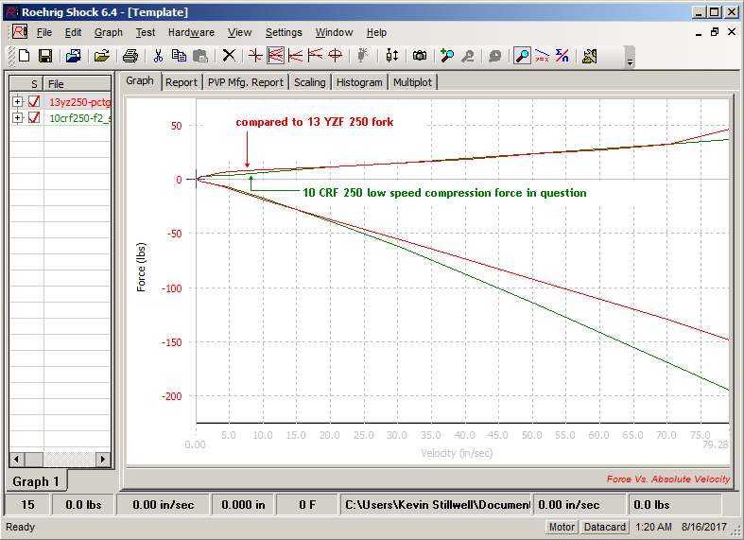

But the graph doesn’t show detail and doesn’t show if the lack of low speed compression is from the base valve or the midvalve.

To see exactly where everything is coming from I use pressure data.

* Through pressure testing we have developed a method to break down the forces in the fork:
  + bv force
  + mv force
  + gas force (from icspring spring)
  + drag force

To start, here is the breakdown of compression forces for the KYB fork (2137).

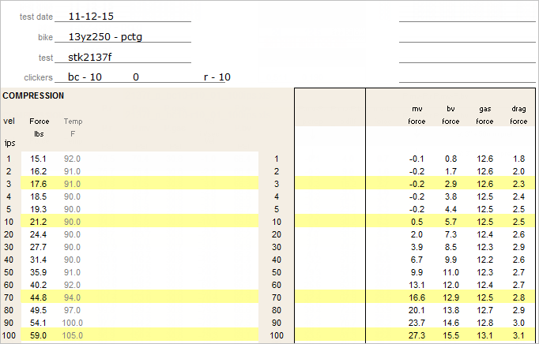

For comparison, here is the breakdown of forces for the Showa fork (1480).

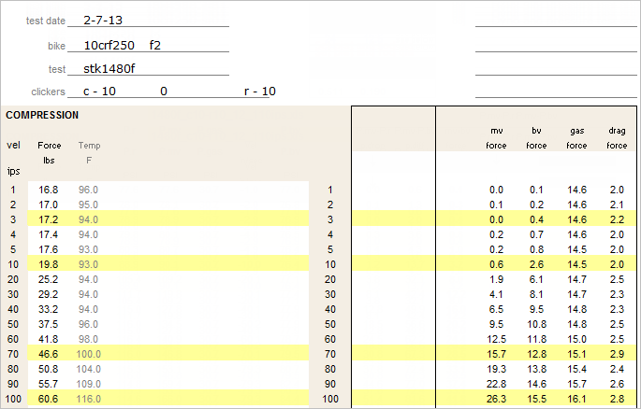

It’s a little easier to compare when they are side-by-side.

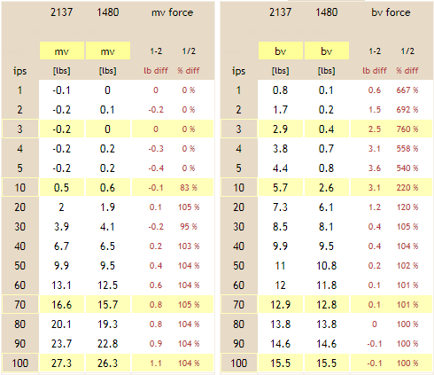

The mv forces are very similar, but the low speed base valve compression force from 1-20 ips is low on the Showa fork. This might not look like much, but from experience we know that the compression forces at the 1-20 ips range are very important.

I like the way my friend in Finland describes it.

* The KYB forks have a firmer / plush feel and do not have the loose-free travel in the first couple inches of the stroke.

So there ya go. If you find this interesting you have my number.

Regards,

Kevin Stillwell