dell / my docs / vdb2_excel / valving_logic_demo_sh / valving_logic_demo_sh_01.doc
1. Login > L2 > mod stacks demo. pg 1

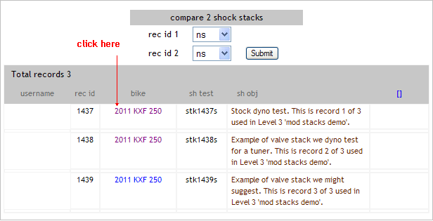

2. The first page is called Rider Info.
We’ll go over the main points on this page, the remaining should be self-explanatory.

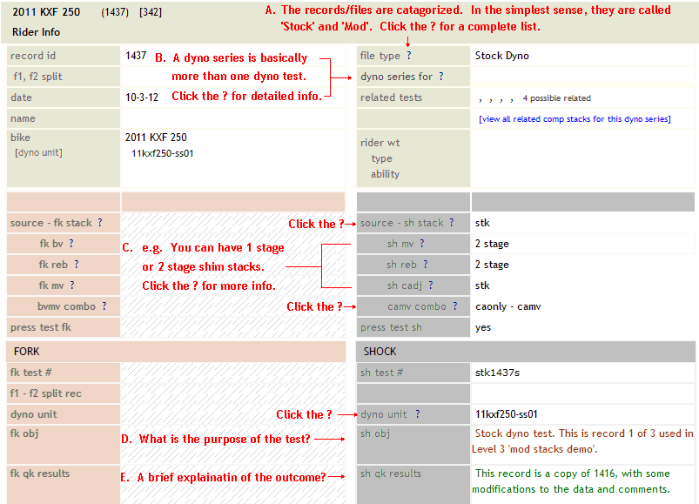

3. Click the ‘Shock Valving’ tab pg 2

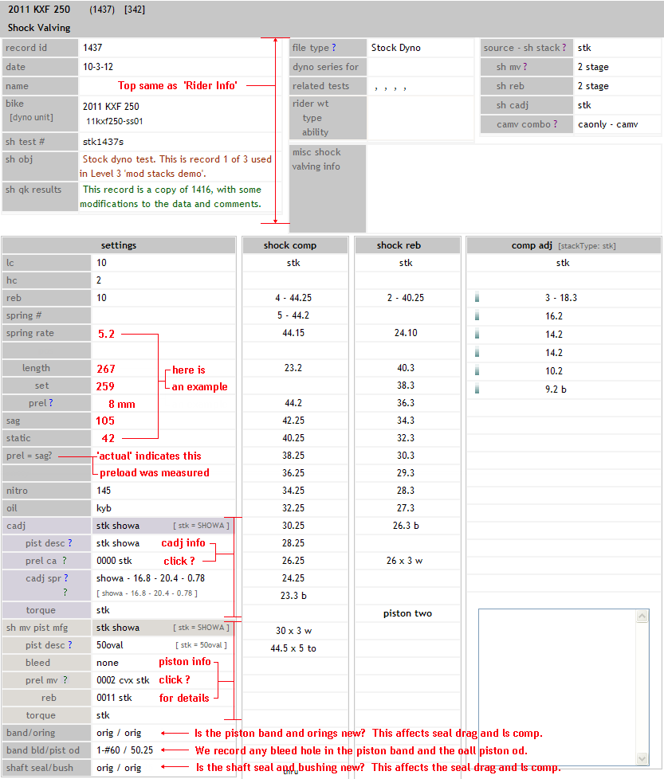

4. Click the ‘Sh Info’ tab. pg 3

This section has detailed information specific to this bikes shock, including some basic
dimensions that can be used to help identify shock components and compatibility.

5. Click the ‘Shock Dyno’ tab.

You can find a short tutorial on how to read and interpret this dyno data at:

click L1 > Dyno Run Info > dyno series tutorial pg1 – pg6

