1). Login > L2 > Mod Stacks Demo

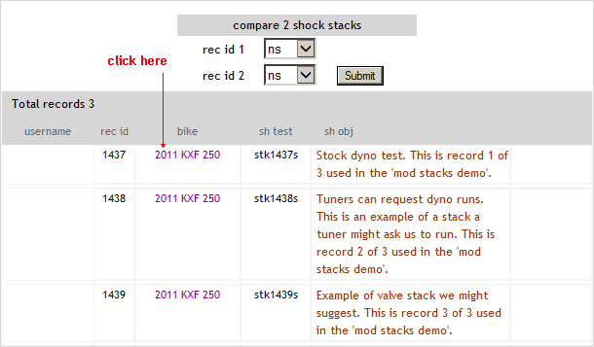

2). The first page is the Rider Info tab. This page shows basic rider info and give some details about the test.

3). Click the ‘Sh Valving’ tab. This page contains all the valving specifications for this record.